**Microservices with API gateway**

**Creating Microservices for account and loan**

**Code:**

**//AccountController.java**

package com.cognizant.account.controller;

import org.springframework.web.bind.annotation.*;

import java.util.Map;

@RestController

@RequestMapping("/accounts")

public class AccountController {

@GetMapping("/{number}")

public Map<String, Object> getAccount(@PathVariable String number) {

return Map.of(

"number", number,

"type", "savings",

"balance", 234343

);

}

}

**//LoanController.java**

package com.cognizant.loan.controller;

import org.springframework.web.bind.annotation.*;

import java.util.Map;

@RestController

@RequestMapping("/loans")

public class LoanController {

@GetMapping("/{number}")

public Map<String, Object> getLoan(@PathVariable String number) {

return Map.of(

"number", number,

"type", "car",

"loan", 400000,

"emi", 3258,

"tenure", 18

);

}

}

**Output:**

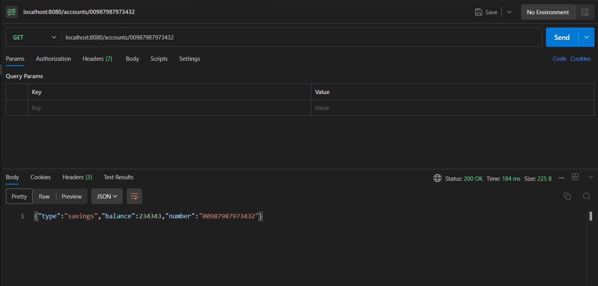

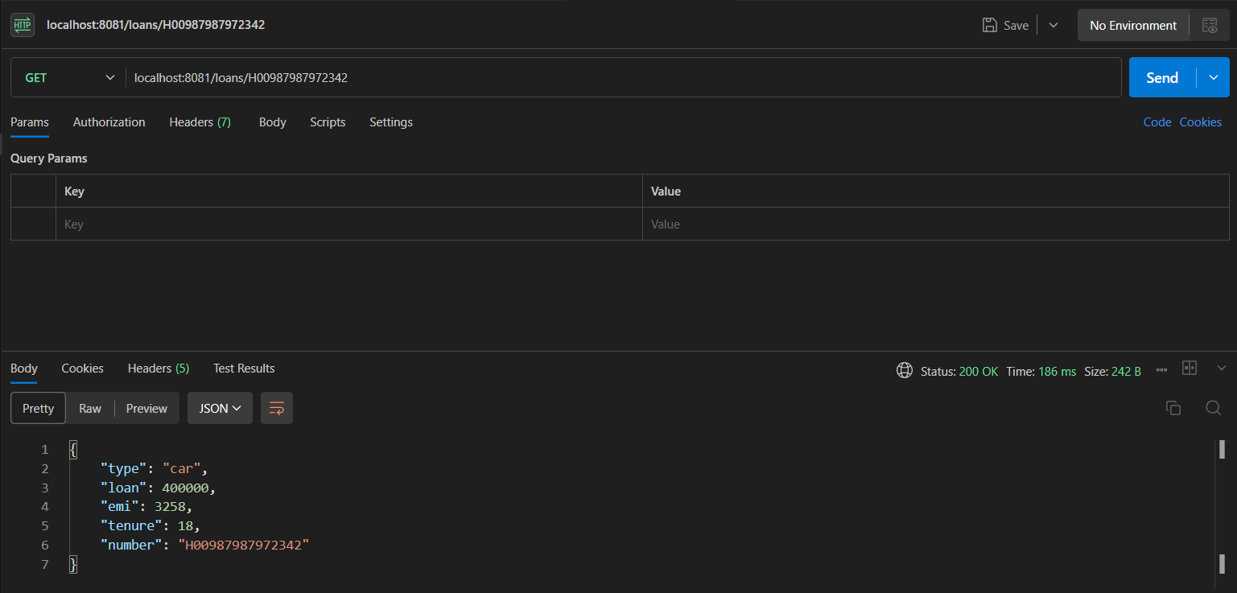

**Create Eureka Discovery Server and register microservices**

**Code:**

**#application.properties**

spring.application.name=eureka-discovery-server

server.port=8761

eureka.client.register-with-eureka=false

eureka.client.fetch-registry=false

logging.level.com.netflix.eureka=OFF

logging.level.com.netflix.discovery=OFF

**//EurekaDiscoveryServerApplication.java**

package com.cognizant.eureka_discovery_server;

import org.springframework.boot.SpringApplication;

import org.springframework.boot.autoconfigure.SpringBootApplication;

import org.springframework.cloud.netflix.eureka.server.EnableEurekaServer;

@SpringBootApplication

@EnableEurekaServer

public class EurekaDiscoveryServerApplication {

public static void main(String[] args) {

SpringApplication.run(EurekaDiscoveryServerApplication.class, args);

}

}

**//AccountApplication.java**

package com.cognizant.account;

import org.springframework.boot.SpringApplication;

import org.springframework.boot.autoconfigure.SpringBootApplication;

import org.springframework.cloud.client.discovery.EnableDiscoveryClient;

@SpringBootApplication

@EnableDiscoveryClient

public class AccountApplication {

public static void main(String[] args) {

SpringApplication.run(AccountApplication.class, args);

}

}

**//LoanApplication.java**

package com.cognizant.loan;

import org.springframework.boot.SpringApplication;

import org.springframework.boot.autoconfigure.SpringBootApplication;

import org.springframework.cloud.client.discovery.EnableDiscoveryClient;

@SpringBootApplication

@EnableDiscoveryClient

public class LoanApplication {

public static void main(String[] args) {

SpringApplication.run(LoanApplication.class, args);

}

}

**//GreetController.java**

package com.cognizant.greet_service.controller;

import org.springframework.web.bind.annotation.RestController;

import org.springframework.web.bind.annotation.GetMapping

@RestController

public class GreetController {

@GetMapping("/greet")

public String sayHello() {

return "Hello World";

}

}

**//GreetServiceApplication.java**

package com.cognizant.greet_service;

import org.springframework.boot.SpringApplication;

import org.springframework.boot.autoconfigure.SpringBootApplication;

import org.springframework.cloud.client.discovery.EnableDiscoveryClient;

@SpringBootApplication

@EnableDiscoveryClient

public class GreetServiceApplication {

public static void main(String[] args) {

SpringApplication.run(GreetServiceApplication.class, args);

}

}

**#application.properties**

spring.application.name=api-gateway

server.port=9090

spring.cloud.gateway.server.webflux.discovery.locator.enabled=true

spring.cloud.gateway.server.webflux.discovery.locator.lower-case-service-id=true

**//ApiGatewayApplication.java**

package com.cognizant.api_gateway;

import org.springframework.boot.SpringApplication;

import org.springframework.boot.autoconfigure.SpringBootApplication;

import org.springframework.cloud.client.discovery.EnableDiscoveryClient;

@SpringBootApplication

@EnableDiscoveryClient

public class ApiGatewayApplication {

public static void main(String[] args) {

SpringApplication.run(ApiGatewayApplication.class, args);

}

}

**Output:**



